Ruh.ai V1 Reference Pack Definition
Construction Project Operations Pack
  - Reusable digital employees for RFI coordination, submittals, document control, reporting, and action tracking across general contractors and specialty contractors
This document instantiates the platform PRD, V1 system design, API contract, and employee pack specification as a concrete industry pack. The goal is to define one horizontal pack that can be configured for many construction firms instead of rebuilding niche one-off workflows for each customer.
What this pack must accomplish  Take repetitive, document-heavy project operations work off project engineers, coordinators, and PMs.  Operate above the customer's existing system of record instead of replacing PMIS and document systems.  Keep all material external actions behind governed approval rules, citations, and full audit history.  Stay horizontal enough to fit many contractors, while still reflecting real construction nouns and workflows. | Document facts  Pack ID: ref.construction.project-ops  Reference version: 1.0.0  Pack type: Industry reference pack  Primary deployment model: One tenant trust boundary; one workspace per project  Conforms to: Ruh.ai V1 Employee Pack Specification

Outcome area | Problems removed | Primary workflows | Business measures
Project correspondence | Work enters through scattered email, chat, PMIS alerts, and file drops with no consistent triage. | Signal intake and routing | Response time, unassigned signal count
Design coordination | Questions are repeated, poorly sourced, or delayed because current drawings/specs are hard to assemble. | RFI lifecycle | Draft-to-submit time, duplicate RFI rate
Vendor review flow | Submittals are incomplete, routed late, and chased manually. | Submittal lifecycle | Cycle time, overdue review count
Team coordination | Meeting prep, action logging, and follow-up consume experienced staff time. | Meeting pack and action sync | Minutes turnaround, overdue action items
Project visibility | Weekly status updates are stitched together by hand from many sources. | Daily and weekly reporting | Hours saved, report turnaround

Why this pack stays horizontal
The pack does not encode one customer's vocabulary or one PMIS vendor as the product. It standardizes the common operating spine of construction project administration: intake, document resolution, RFI coordination, submittal coordination, reporting, and follow-through. Tenant overlays map the pack to each contractor's terminology, permissions, and systems.

Executive snapshot
The Construction Project Operations Pack is a governed digital-employee bundle for active project execution. It assumes the contractor already has at least one digital system of record - typically a PMIS, a document repository, and team communication channels - but is still spending too many human hours classifying inbound requests, assembling document context, drafting coordination artifacts, chasing overdue items, and preparing recurring reports.
The pack exports six default employee templates, six repeatable workflows, connector bindings for PMIS/document/messaging systems, policy profiles for low-to-high-risk actions, and eval suites that prove citation quality, routing correctness, stale-document detection, and approval compliance before promotion.
Pack area | V1 reference definition
Employees | Project intake coordinator; document controller; RFI coordinator; submittal coordinator; meeting & reporting analyst; action & risk tracker
Core workflows | Correspondence intake; RFI lifecycle; submittal lifecycle; meeting pack + action sync; daily/weekly reporting; issue/risk watchlist
Supported capability groups | PMIS read/write; document repository read/write; email/chat; calendar read; reporting export; optional schedule read
Non-negotiable controls | Citation-first drafting; document revision awareness; human approval for material external writes; immutable audit log
Pilot slice | Intake, RFI, submittal, meeting/action workflows on 2-3 active projects

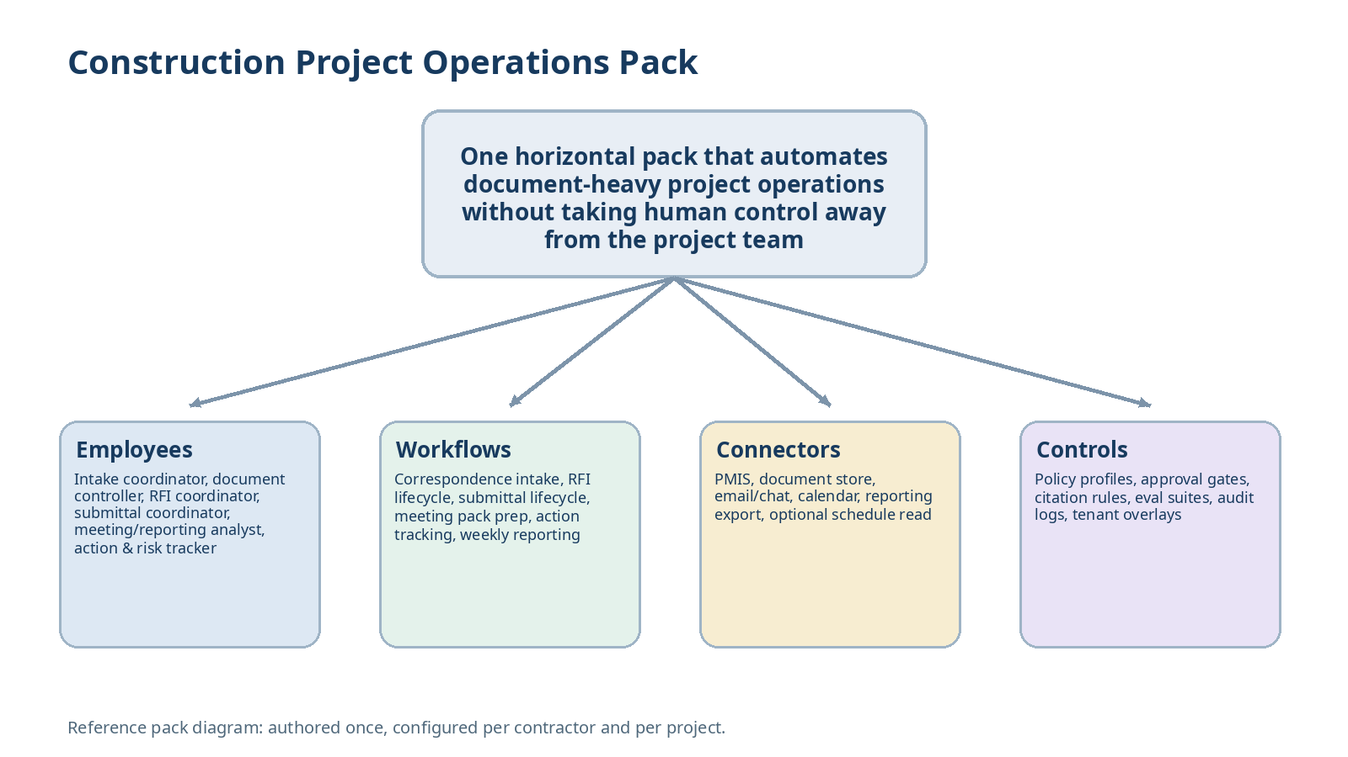
Figure 1. The construction pack bundles employees, workflows, connectors, and controls into one reusable distribution unit.
1. Purpose, scope, and design goals
The purpose of this pack is to operationalize the digital-employee platform in the part of construction where cross-company repetition is strongest: document-heavy project operations. The pack should be usable by a general contractor, a larger specialty contractor, or an owner's representative with light overlay changes rather than bespoke workflow engineering.
The pack is intentionally narrow in what it automates. It removes administrative drag around coordination, documentation, and follow-through. It does not try to automate field means-and-methods decisions, safety-critical instructions, contractual commitments, or schedule resequencing without direct human ownership.
Must sit above, not replace, the customer's PMIS, document repository, email, and chat systems.
Must produce structured artifacts and citations instead of free-form chatbot outputs.
Must let humans approve external write-backs, owner/designer communication, and any action that changes project record.
Must support one workspace per project so context, documents, and approvals stay scoped correctly.
1.1 Out of scope for V1
Autonomous schedule changes, financial commitments, pay application decisions, or procurement commitments.
Safety instructions, means-and-methods recommendations, or field directives that can change physical work without human sign-off.
Replacing Procore, Autodesk Construction Cloud, SharePoint, Teams, email, or the firm's existing document approval process.
2. Target operating model and deployment assumptions
Dimension | Reference assumption | Why it matters
Tenant boundary | One contractor or owner organization per deployment boundary | Matches the platform trust model and keeps secrets, approvals, and audit logs isolated.
Workspace model | One workspace per project; optional portfolio workspace for leadership reporting | Prevents document and action contamination across jobs.
Primary operators | Project engineer, project manager, coordinator, document control lead, operations leader | These roles feel the coordination pain first and can approve outputs.
System of record | At least one PMIS and one document repository are already in use | The pack writes back into real workflows instead of creating a parallel shadow system.
Message channels | Email plus Slack or Teams are present; calendar access is available for meeting workflows | The pack must meet teams where they already work.
Rollout mode | Pilot 2-3 active projects before portfolio template rollout | Needed to tune vocabulary, approval rules, and provider overlays.

Supported customer archetypes
General contractor with PM/PE-heavy document coordination burden.
Specialty contractor managing shop drawings, RFIs, and submittals with lean office staff.
Owner's rep or construction management firm that needs cleaner status summaries and action tracking across projects.

3. Pack identity, dependency model, and exported assets
This pack is an industry reference pack, not a provider pack. It declares normalized construction capabilities and exported employee templates while relying on provider overlays to bind those capabilities to Procore, Autodesk Construction Cloud, SharePoint, Box, Teams, Slack, email, and other supported systems.
Manifest field | Reference value
id | ref.construction.project-ops
version | 1.0.0
packType | industry-reference
dependsOn | ruh.foundation.runtime; ruh.foundation.approvals; ruh.foundation.documents; provider overlays
exports.employeeTemplates | 6
exports.workflowTemplates | 6
defaultPolicyProfile | construction-project-ops-default
defaultEvalSuite | construction-project-ops-core

3.1 Suggested source tree
construction.project-ops/
pack.yaml
README.md
employees/
intake-coordinator.yaml
document-controller.yaml
rfi-coordinator.yaml
submittal-coordinator.yaml
meeting-reporting-analyst.yaml
action-risk-tracker.yaml
workflows/
correspondence-intake.yaml
rfi-lifecycle.yaml
submittal-lifecycle.yaml
meeting-pack-action-sync.yaml
daily-weekly-reporting.yaml
issue-risk-watchlist.yaml
artifacts/
intake-brief.schema.json
rfi-draft.schema.json
submittal-completeness.schema.json
meeting-pack.schema.json
action-register-delta.schema.json
skills/
document-resolution/
pmis-writeback/
report-export/
evals/
routing/
citations/
approvals/
stale-document-detection/
overlays/
gc-default.overlay.yaml
specialty-default.overlay.yaml

4. Canonical objects and construction vocabulary
The reference pack can only stay reusable if it normalizes construction nouns before they reach employee prompts or workflow logic. Provider-specific field names are adapter concerns; the pack works against a canonical object model.
Canonical object | Description | Representative source systems
Project | The workspace root. Holds participants, phases, cost codes, calendars, and policy bindings. | PMIS, ERP, CRM
Document | Any managed file or record with title, type, revision, discipline, and status. | PMIS, SharePoint, Box
Drawing / sheet | Revision-controlled design drawing or sheet reference. | PMIS, file store
Spec section | Specification section or clause used for submittal/RFI context. | Specs PDFs, PMIS
RFI | Question record with cited sources, due date, status, answer, and impacted parties. | PMIS, email
Submittal | Package or item requiring completeness check, routing, comments, and return. | PMIS
Meeting | Scheduled coordination event with agenda, notes, and linked actions. | Calendar, docs
Action item | Tracked commitment with owner, due date, source meeting/signal, and status. | Docs, task system
Daily log | Daily activity narrative, key events, issues, weather, or manpower record. | PMIS
Issue / risk | Open concern requiring monitoring or escalation. | PMIS, risk log, notes
Change event | Potential project change identified through correspondence or issue tracking. | PMIS, logs

4.1 Document resolution rules
Every external draft must cite the latest approved or referenced document revision used to generate it.
If two active sources conflict, the pack must surface the conflict rather than choosing silently.
If a required attachment or spec reference is missing, the employee returns an incompleteness result instead of improvising.
The document controller owns canonical source resolution and provides citation bundles to specialist employees.
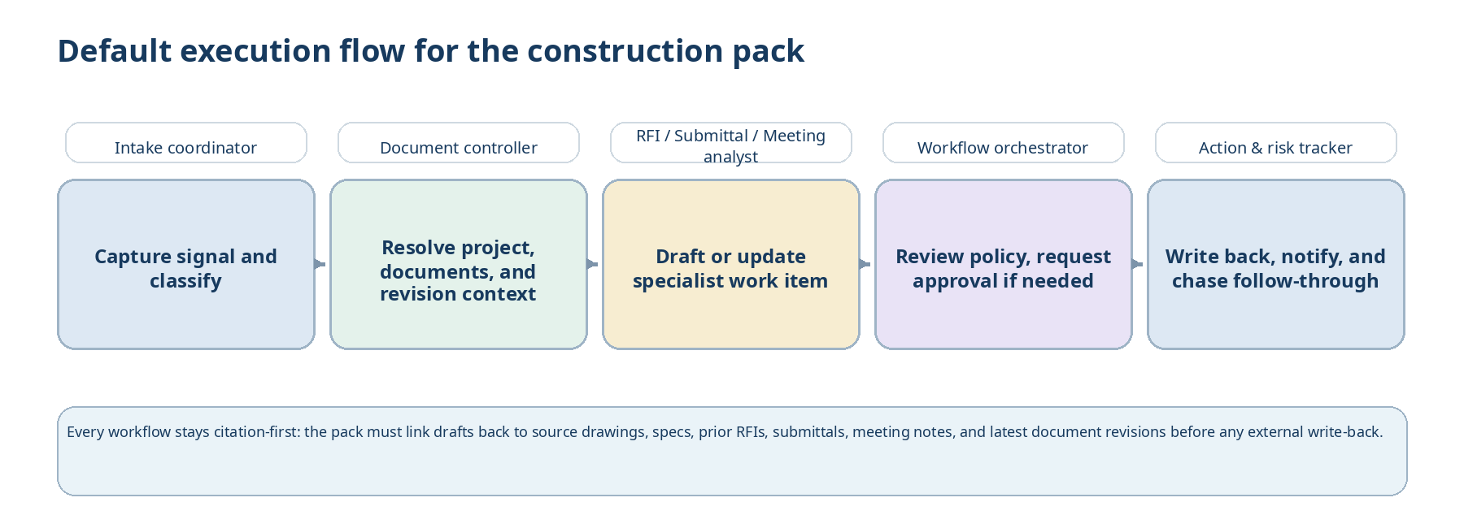
Figure 2. Default collaboration pattern for construction workflows: intake and document resolution feed the specialist employee, while the orchestrator and action tracker govern follow-through.
5. Employee roster and collaboration contract
The pack exports six default employee templates. Each employee has one primary lane of responsibility. Cross-employee collaboration happens through typed tasks and structured artifacts created by the Ruh.ai orchestrator; employees may request subtasks, but they do not create shadow state outside the workflow engine.
Employee | Primary lane | Default risk tier | What success looks like
Project intake coordinator | Capture inbound signal, classify it, link it to a project, and route the right workflow. | Low | Nothing important sits unassigned in email/chat/PMIS alerts.
Document controller | Resolve document context, revisions, and metadata for downstream work. | Low-Medium | Specialist employees always receive the right source bundle.
RFI coordinator | Prepare RFI drafts, duplicate checks, and response summaries. | Medium | High-quality RFI packages with citations and fewer duplicates.
Submittal coordinator | Check completeness, route reviewers, and consolidate return comments. | Medium | Shorter review cycles and fewer incomplete packages.
Meeting & reporting analyst | Prepare agendas, packs, summaries, and recurring reports. | Low-Medium | Fast turnaround on packs and summaries.
Action & risk tracker | Maintain commitments, due dates, reminders, and risk watchlists. | Medium | Fewer overdue actions and cleaner status visibility.

5.1 Project intake coordinator
Field | Definition
Purpose | Turns fragmented inbound work into clean, project-scoped task records. It is the front door for email, chat, PMIS notifications, uploaded files, and user-submitted requests.
Primary triggers | Inbound email/chat message; new PMIS alert; file upload; manually submitted task request.
Accepts tasks | raw_signal.normalize; project.lookup; route.recommendation
Produces | Intake brief; proposed project/workflow route; severity and due-date hints; source bundle links.
Capabilities | messaging.read; docs.search; pmis.read; directory.lookup; task.write-internal
Default approval profile | Auto for internal task creation. Approval required for any outbound draft to an external recipient.
Key KPIs | Signal-to-route time; orphaned signal count; routing precision.

5.2 Document controller
Field | Definition
Purpose | Resolves the document context for downstream employees by identifying the right drawings, spec sections, prior records, revisions, and missing references.
Primary triggers | Task from intake; workflow step needing source bundle; stale-document warning.
Accepts tasks | document.resolve; revision.check; source.bundle.assemble
Produces | Citation bundle; document register delta; conflict/missing-source alerts.
Capabilities | docs.read; docs.metadata.write; pmis.read; search.index.read
Default approval profile | Auto for internal metadata tagging. Approval required for any external publication or official record change.
Key KPIs | Correct revision selection; stale-source detection recall; missing-reference detection.

5.3 RFI coordinator
Field | Definition
Purpose | Drafts RFIs and related follow-up summaries using validated document context rather than ad-hoc free text.
Primary triggers | Unresolved design question; issue escalated from meeting/action flow; PM/PE request.
Accepts tasks | rfi.prepare; rfi.duplicate-check; rfi.response.summarize
Produces | RFI draft; duplicate analysis; due-date suggestion; response-impact summary.
Capabilities | pmis.read/write-draft; docs.read; messaging.draft; export.pdf
Default approval profile | Human approval required before creating or transmitting an official external RFI.
Key KPIs | Draft-to-approval time; duplicate RFI reduction; citation completeness.

5.4 Submittal coordinator
Field | Definition
Purpose | Automates the clerical work around submittal completeness, routing, reminder management, and comment consolidation.
Primary triggers | New vendor submittal; PMIS submittal state change; overdue review window.
Accepts tasks | submittal.check; submittal.route; submittal.return.package
Produces | Completeness report; reviewer routing list; reminder notifications; consolidated return package draft.
Capabilities | pmis.read/write-draft; docs.read; messaging.draft; calendar.read
Default approval profile | Approval required for final external return package or reviewer assignment updates that change the official record.
Key KPIs | Cycle time; incomplete-package detection precision; overdue-review reduction.

5.5 Meeting & reporting analyst
Field | Definition
Purpose | Packages project status into recurring internal and external summaries without forcing senior staff to assemble every artifact by hand.
Primary triggers | Scheduled meeting; end-of-day or end-of-week schedule; PM/leadership request.
Accepts tasks | meeting.pack.prepare; report.weekly.generate; summary.compose
Produces | Agenda; meeting pack; meeting notes draft; daily/weekly report draft; executive summary.
Capabilities | calendar.read; docs.read/write-draft; pmis.read; export.pdf
Default approval profile | External distribution requires approval. Internal drafts and working packs may auto-generate.
Key KPIs | Minutes turnaround; report prep time; action extraction quality.

5.6 Action & risk tracker
Field | Definition
Purpose | Owns the follow-through layer by maintaining action items, reminders, overdue notifications, and simple issue/risk watchlists.
Primary triggers | Meeting notes; RFI/submittal status changes; overdue thresholds; manual update request.
Accepts tasks | action.register.update; reminder.send; risk.watchlist.update
Produces | Action register delta; reminder queue; overdue digest; risk watchlist updates.
Capabilities | task.read/write; pmis.read/write-limited; messaging.notify; report.export
Default approval profile | Auto for internal reminders and internal task updates. Approval required for external owner/designer notifications.
Key KPIs | Overdue action count; reminder timeliness; status freshness.

6. Workflow catalog
Each workflow below is pack content, not bespoke implementation logic. The orchestrator materializes official task records, assigns the primary employee, enforces approval gates, and records artifacts. Employees produce proposals and outputs; the workflow engine owns business state.
Workflow | Primary trigger | Employee pattern | What the workflow does | Approval gate | Primary measures
Correspondence intake and project routing | Inbound email/chat/PMIS signal | Intake coordinator -> document controller as needed | Normalize signal, detect project, classify intent, create task, notify owner | Mostly auto; external reply draft requires approval | Signal-to-route time; routing precision
RFI lifecycle | User request or unresolved coordination issue | RFI coordinator with document controller support | Resolve source bundle, check duplicates, draft RFI, request approval, write back, monitor response, summarize answer | Official RFI creation or send requires approval | Draft-to-submit time; duplicate rate
Submittal lifecycle | New vendor package or PMIS state change | Submittal coordinator with action tracker | Check completeness, route reviewers, chase overdue reviews, consolidate comments, prepare return package | Final return or official reviewer update requires approval | Cycle time; overdue-review reduction
Meeting pack and action sync | Scheduled meeting or recurring cadence | Meeting/reporting analyst + action tracker | Gather open items, draft agenda, compile pack, summarize notes, update action register, chase owners | External distribution requires approval | Minutes turnaround; action freshness
Daily and weekly reporting | Daily or weekly cron schedule | Meeting/reporting analyst | Aggregate updates, issues, trends, photos/notes, draft report, route for review, publish | External publication requires approval | Report turnaround; hours saved
Issue and risk watchlist | New issue, overdue trend, repeated blocker | Action & risk tracker | Cluster related signals, update watchlist, recommend escalation, notify PM/leadership | Escalation messages outside the team require approval | Emerging risk detection; overdue-item reduction

6.1 MVP workflow slice
Pilot intake and routing on every project from day one because clean task creation is required for all downstream value.
Make RFI lifecycle and submittal lifecycle the first specialist workflows because they are repetitive, visible, and measurable.
Add meeting pack and action sync in the pilot because it proves recurring value and closes the loop on follow-through.
Hold daily/weekly reporting and issue/risk watchlist behind the first round of tuned templates unless a customer already has structured inputs.
7. Connector and capability profile
The pack declares capability groups first and provider bindings second. This keeps the pack horizontal across contractors while allowing one tenant to bind PMIS capability to Procore and another to Autodesk Construction Cloud.
Capability group | Required? | Typical providers | Pack usage
pmis.read | Yes | Procore; Autodesk ACC; other supported PMIS adapters | Read RFIs, submittals, status fields, contacts, and issue logs.
pmis.write-draft | Yes | Procore; Autodesk ACC | Create or update draft records behind approval gates.
docs.read | Yes | SharePoint; OneDrive; Box; Google Drive; PMIS docs | Resolve drawings, specs, attachments, and meeting source material.
docs.metadata.write | Recommended | SharePoint; Box; internal index | Tag or index documents and maintain internal source bundles.
messaging.read | Yes | Email; Teams; Slack | Capture inbound signals and reminders.
messaging.draft/notify | Yes | Email; Teams; Slack | Prepare drafts and send internal reminders.
calendar.read | Recommended | Outlook; Google Calendar | Find meeting context and publish meeting-pack timing.
schedule.read | Optional | Primavera P6; Microsoft Project | Enrich weekly summaries and lookahead notes without making schedule decisions.
report.export | Yes | PDF / DOCX / HTML export service | Generate meeting packs, summaries, and reusable attachments.

7.1 Minimum provider overlays
providers:
pmis:
adapter: procore | autodesk-acc
documents:
adapter: sharepoint | onedrive | box | google-drive
messaging:
inbound: email
teamChat: teams | slack
calendar:
adapter: outlook | google
policies:
externalApprovalGroup: project_manager
internalReminderChannels:
- teams:project-ops

8. Policy, approval, and safety model
Construction workflows look routine until an automation touches an official record or sends something that changes project obligations. The default policy profile therefore separates low-risk internal work from material external actions.
Representative action | Default treatment | Notes
Classify an inbound email or chat message | Auto | Internal read-only action; always logged.
Create an internal task record in Ruh.ai | Auto | Reversible and internal.
Tag a document or assemble a citation bundle | Auto | Internal metadata operation.
Draft an RFI, submittal return memo, or meeting minutes | Auto draft | Artifact produced internally first; no transmission.
Create an official RFI or submittal record in PMIS | Approval required | Human must verify content, recipient, and impact.
Send external communication to owner, architect, engineer, or vendor | Approval required | Logged with artifact, source citations, and approver.
Change schedule dates, cost commitments, or contractual terms | Human only | Out of scope for unattended automation.
Issue safety or field directives | Forbidden | Not allowed in this pack.

Approval rule design principle
The pack earns trust by automating assembly, analysis, and follow-through first. It does not earn trust by acting autonomously where the customer's legal, contractual, or physical risk materially increases.

9. Canonical artifacts and sample contracts
Every workflow must emit structured artifacts that can be stored, reviewed, versioned, and replayed. The pack does not rely on unstructured chat output as the official interface between employees and humans.
Artifact | Produced by | Required fields
Intake brief | Intake coordinator | sourceRefs; proposedProject; signalType; priority; recommendedWorkflow; openQuestions
Citation bundle | Document controller | documentRefs; revisionRefs; conflicts; missingSources; confidence
RFI draft | RFI coordinator | subject; question; citedSources; proposedDueDate; impactedAreas; draftRecipients
Submittal completeness report | Submittal coordinator | submittalId; requiredAttachments; missingItems; routingProposal; confidence
Meeting pack | Meeting/reporting analyst | agenda; openItems; statusSummary; attachedArtifacts; discussionPrompts
Action register delta | Action & risk tracker | newItems; updates; overdueItems; remindersQueued
Weekly executive summary | Meeting/reporting analyst | wins; blockers; overdueCounts; trendFlags; escalationNeeds

9.1 Sample workflow input
task:
type: rfi.prepare
workspaceRef: project:ACME-Hospital-Tower
sourceRefs:
- email:thread:8931
- docs:drawing:A6.21:rev-4
- docs:spec:09-29-00
requester:
personRef: user:pe-104
requestedDueDate: 2026-04-14
context:
location: "Level 5 west corridor"
discipline: "interiors"

9.2 Sample RFI draft output
artifact:
type: rfi-draft
title: "Clarification requested for corridor soffit height at Level 5 west corridor"
question: >
Please confirm the required soffit height and detail priority where drawing A6.21 rev 4
and specification section 09 29 00 appear to conflict at the Level 5 west corridor ceiling line.
citedSources:
- docs:drawing:A6.21:rev-4
- docs:spec:09-29-00
relatedRecords:
- pmis:rfi:RFI-042
confidence: 0.91
approvalRequired: true

10. Eval suite and release gates
Because this pack writes into real project workflows, evaluation is mandatory. The reference pack ships scenario sets that verify both role behavior and policy enforcement before any tenant promotion.
Eval family | What it checks | Suggested release threshold
Routing evals | Correct project and workflow classification from messy inbound signals | >= 0.90 weighted accuracy on reference set
Citation and revision evals | Correct source resolution and stale-document detection | No critical stale-source misses; >= 0.95 citation completeness
RFI draft quality evals | Clear question framing, duplicate awareness, and required fields | >= 0.85 reviewer acceptance
Submittal completeness evals | Detection of missing attachments, spec mapping, and routing suggestions | >= 0.90 precision on missing-item detection
Action extraction evals | Extraction of commitments and due dates from meeting notes | >= 0.88 F1 on action-item extraction
Policy enforcement evals | Approval prompts, blocked actions, and forbidden-action refusal | 100% pass on high-risk policy tests

No pack release is promotable if policy tests fail, even when artifact quality is high.
Tenant promotion requires at least one overlay-specific smoke test against the customer's provider bindings.
Production incidents must feed new eval cases back into the pack before the next minor release.
11. MVP deployment plan for the reference pack
Phase | What ships | Definition of success
Phase 1 - project foundation | Tenant overlay, project workspace creation, intake coordinator, document controller, baseline audit logs | Signals route correctly and document bundles resolve.
Phase 2 - specialist workflows | RFI coordinator, submittal coordinator, PMIS draft write-back, approval UI | Draft artifacts are used in the team's daily work.
Phase 3 - recurring coordination | Meeting/reporting analyst, action & risk tracker, reminder and report exports | Recurring meeting and follow-through work measurably shrinks.
Phase 4 - portfolio reuse | Overlay hardening, template tuning, cross-project reporting, release gates for wider rollout | Customer can onboard additional projects with low incremental setup.

Pilot success metrics
Reduction in average time from inbound signal to assigned owner.
Reduction in RFI draft preparation time and duplicate RFI occurrences.
Reduction in submittal overdue-review count.
Reduction in meeting-minutes turnaround time and overdue action items.

12. Example manifest and overlay excerpts
12.1 Manifest excerpt
id: ref.construction.project-ops
version: 1.0.0
packType: industry-reference
dependsOn:
- ruh.foundation.runtime@^1.0
- ruh.foundation.approvals@^1.0
- ruh.foundation.documents@^1.0
exports:
employeeTemplates:
- construction.intake-coordinator.v1
- construction.document-controller.v1
- construction.rfi-coordinator.v1
- construction.submittal-coordinator.v1
- construction.meeting-reporting-analyst.v1
- construction.action-risk-tracker.v1
workflowTemplates:
- construction.correspondence-intake.v1
- construction.rfi-lifecycle.v1
- construction.submittal-lifecycle.v1
- construction.meeting-pack-action-sync.v1
- construction.daily-weekly-reporting.v1
- construction.issue-risk-watchlist.v1
defaultPolicyProfile: construction-project-ops-default
defaultEvalSuite: construction-project-ops-core

12.2 Tenant overlay excerpt
tenant:
name: "Sample GC"
operatingModel: general-contractor
workspaceMode: per-project
providers:
pmis:
adapter: procore
documents:
adapter: sharepoint
messaging:
inbound: email
teamChat: teams
calendar:
adapter: outlook
policies:
externalApprovalGroup:
- role: project-manager
- role: senior-project-engineer
forbiddenActions:
- schedule.commit
- safety.directive
- contract.term.change
vocabulary:
submittalAlias: "shop drawing package"
actionItemAlias: "follow-up item"

Appendix A. Runtime mapping example
Exported employee | Compiled OpenClaw agent id | Workspace bootstrap files | Primary skill groups
construction.intake-coordinator.v1 | proj-<id>-intake | SOUL.md; AGENTS.md; intake-routing.md | message-intake; project-resolution
construction.document-controller.v1 | proj-<id>-docctrl | SOUL.md; AGENTS.md; source-resolution.md | document-resolution; revision-check
construction.rfi-coordinator.v1 | proj-<id>-rfi | SOUL.md; AGENTS.md; rfi-playbook.md | rfi-drafting; pmis-writeback
construction.submittal-coordinator.v1 | proj-<id>-submittal | SOUL.md; AGENTS.md; submittal-playbook.md | submittal-check; reminder-management
construction.meeting-reporting-analyst.v1 | proj-<id>-reporting | SOUL.md; AGENTS.md; reporting-playbook.md | meeting-pack; report-export
construction.action-risk-tracker.v1 | proj-<id>-actions | SOUL.md; AGENTS.md; follow-through.md | action-register; risk-watch

Appendix B. Source assumptions
The references below anchor the OpenClaw runtime assumptions used by this reference pack and should be revisited whenever the runtime adapter changes.
[R1] OpenClaw CLI - agents (isolated agents with workspaces, auth, and routing) - https://docs.openclaw.ai/cli/agents
[R2] OpenClaw tools - skills (AgentSkills-compatible skill folders) - https://docs.openclaw.ai/tools/skills
[R3] OpenClaw automation - hooks - https://docs.openclaw.ai/automation/hooks
[R4] OpenClaw automation - cron jobs - https://docs.openclaw.ai/automation/cron-jobs
[R5] OpenClaw gateway - sandboxing - https://docs.openclaw.ai/gateway/sandboxing
[R6] OpenClaw gateway - security - https://docs.openclaw.ai/gateway/security

